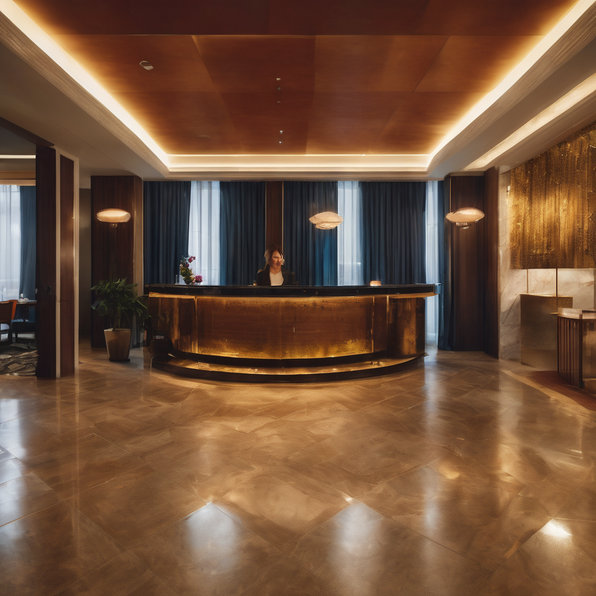

**Hotel Coopergates Revenue Decline**

Contents

1 Pre-Define Phase 3

1.1 Sales record analysis 3

1.2 Pareto Chart for Lost account VOC 6

2 Define Phase 7

2.1 Project Charter 8

2.2 Cost Benefit Analysis 9

2.3 RACI Model: 9

2.4 SIPOC 13

3 Measure Phase 13

3.1 Fishbone Diagram 14

3.2 Pareto chart – causes for delay in check-in time 15

3.3 Perto chart – Causes of overbookings 16

3.4 Analysis of Guest check-in duration 19

3.5 Process Stability Check 20

3.6 Process stability 21

4 Analyse Phase 22

5 Improve Phase 26

5.1 Pilot test – T-test 28

5.2 Pilot test – F-test 29

5.3 Chi-Square test 30

6 Control Phase 31

6.1 Control Phase: Final steps 31

7 Conclusion: 32

# Pre-Define Phase

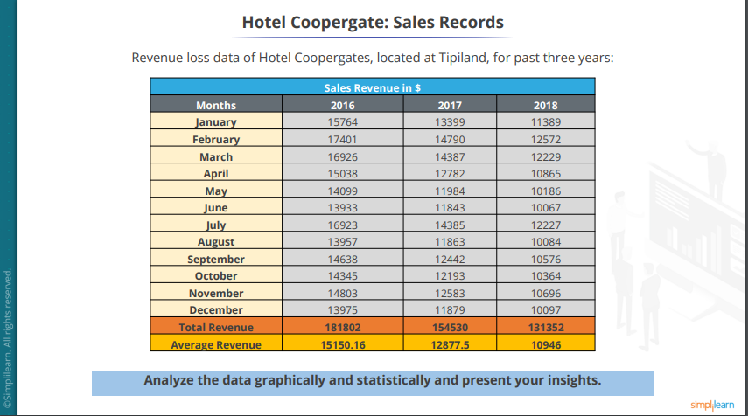

## Sales record analysis

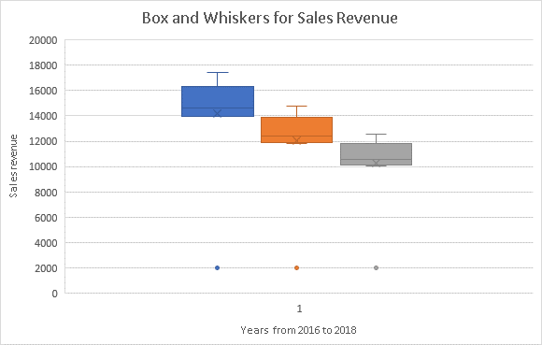

**Interpretation: Sales revenue reduced from 2016 to 2018. By analyzing the graph, I can say there are no outliers.**

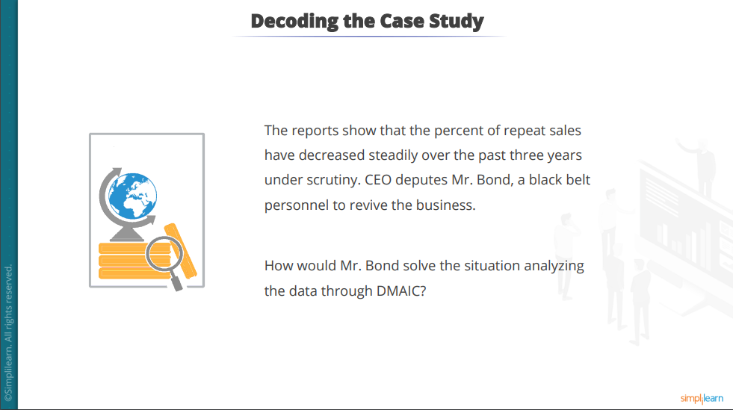

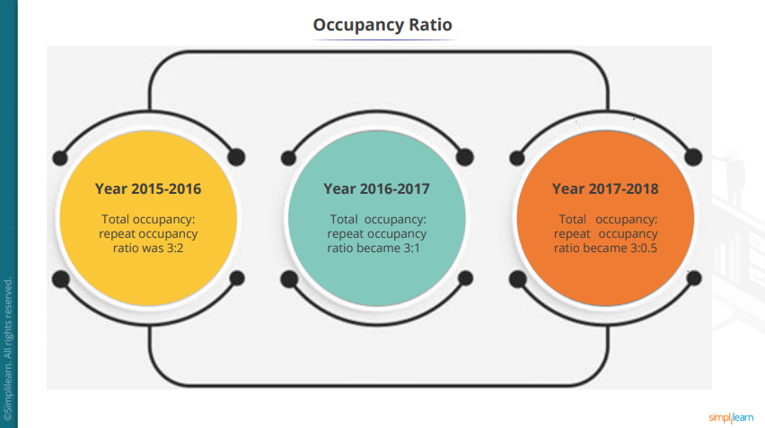

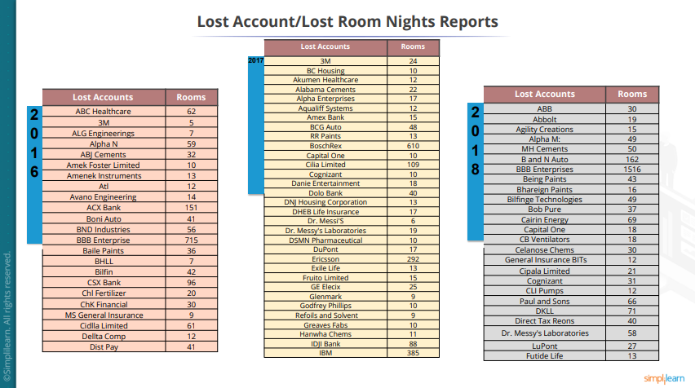

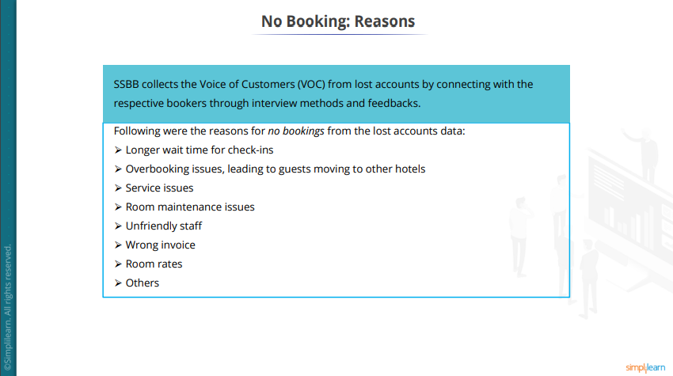

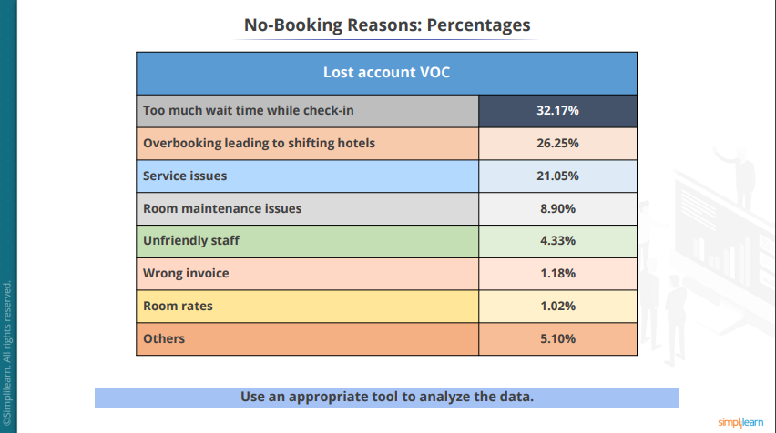

## Pareto Chart for Lost account VOC

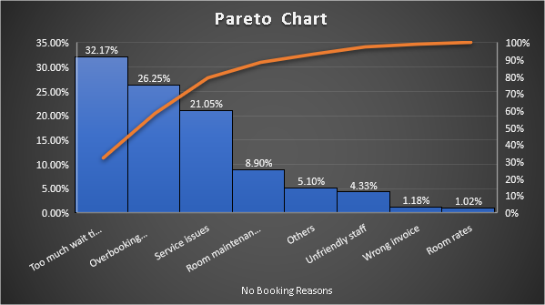

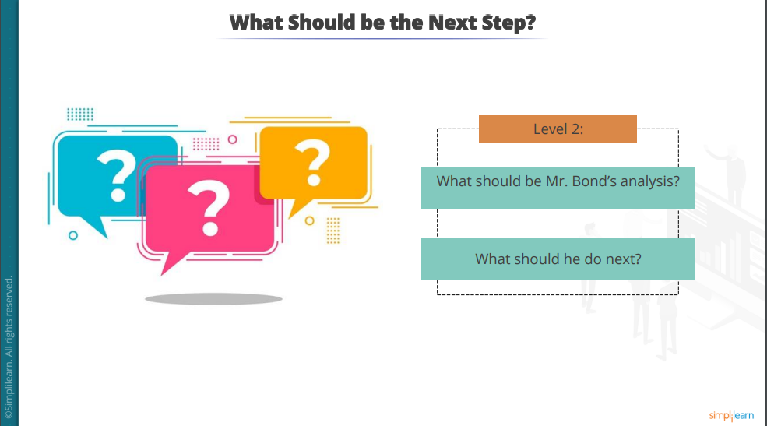

# Define Phase

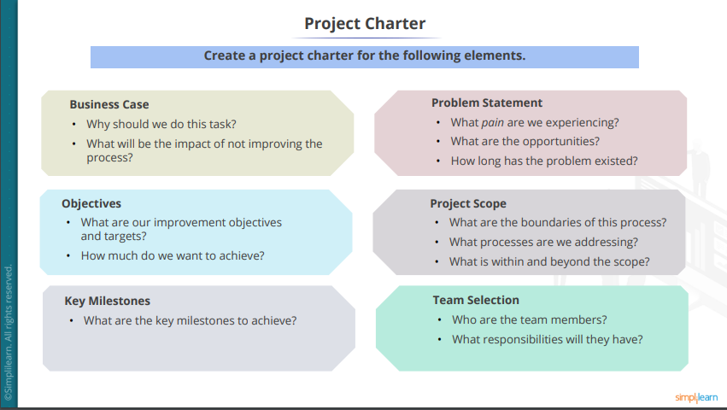

## Project Charter

**RKM**

Project Charter Document

**Project Name: Rexon Movie Theatre**



**PROJECT CHARTER PURPOSE:**

The project needs to be done to increase repeat sales. It is been observed that repeat sales have decreased steadily over the past three years.

**Problem Statement:**

* The hotel is steadily losing revenue by 15% every year due to a decrease in repeat sales by 50% yearly even after spending 7% of the total budget revenue earned on BTL activities, online promotions, PR Parties, and travel planner entertainment.
* This has reduced the **Gross Operating Process** from 32% in 2014 to -8% in 2017, resulting in a threat to the services and quality of the hotel, which may lead to loss of **Star Category**.

**Objectives (Goal Statement):**

Improving upon the hotel services by 10 folds in the next 12 months by reducing:

* The average check-in time is from 12 minutes to 4 minutes.
* The number of guests moving due to overbooking from an average of 11 per day to 3 per day which will improve the Gross Operating Process by 8%-10%.
* The service issues by 30%.

**Business Case:**

* Improvement in hotel services will result in recovery from losses, which will break even the Gross Operating Process and bring stability in cash flow by 8% to 10% over the next 12 months, revive the lost market share, increase profitability by 10% per annum from the subsequent year and regain brand value.
* If the loss in revenue is not arrested at this stage, further revenue loss will result in staff layover and decrease the hotel standards, which may lead to hotel shutdown or takeover by comp set.

**Project Scoping:**

* This project will be plugging out all the major glitches in guest services (Check-in duration, overbooking issues, and service issues) to make the stay a **delight.**
* The project will focus on the retention of existing accounts and the reviving of lost accounts.

**Prepared by** Rathish Kumar Manjunath

## Cost Benefit Analysis

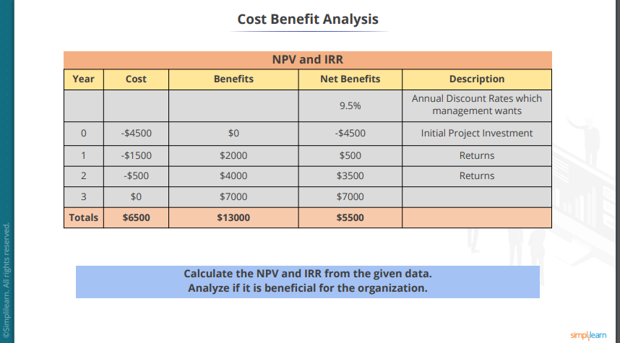

**NPV = 3842.22**

**IRR = 42%**

## RACI Model:

|  |  |  |  |  |  |
| --- | --- | --- | --- | --- | --- |
| Team Members | Define | Measure | Analyse | Improve | Control |
| Black Belt | R/A | A | R/A | A | A |
| Green Belt | R | R |  | R |  |
| Guest Relationship Executive | C | C | C | C | R |
| Process Manager | C | C | C | A | R |
| Financial Representative |  |  | I |  |  |

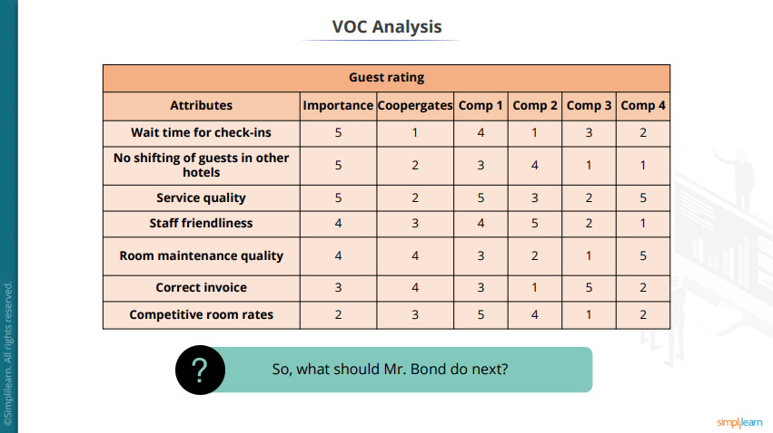

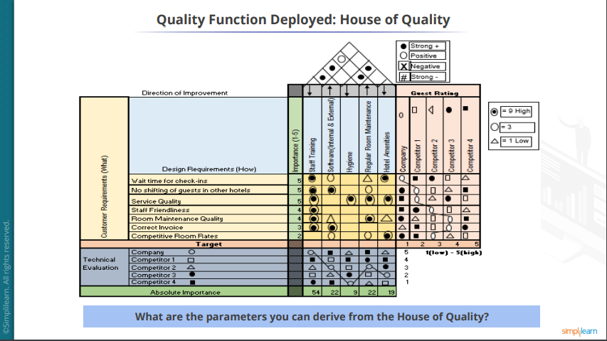

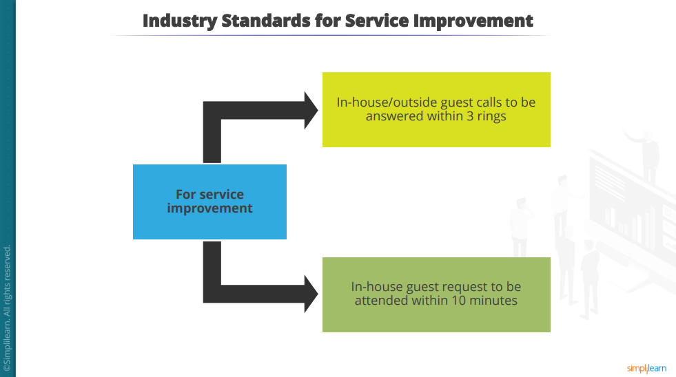

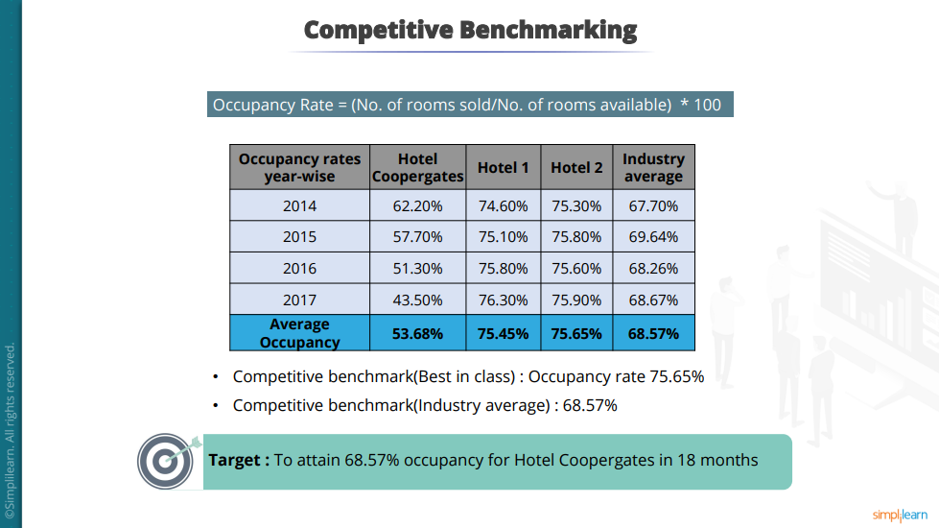

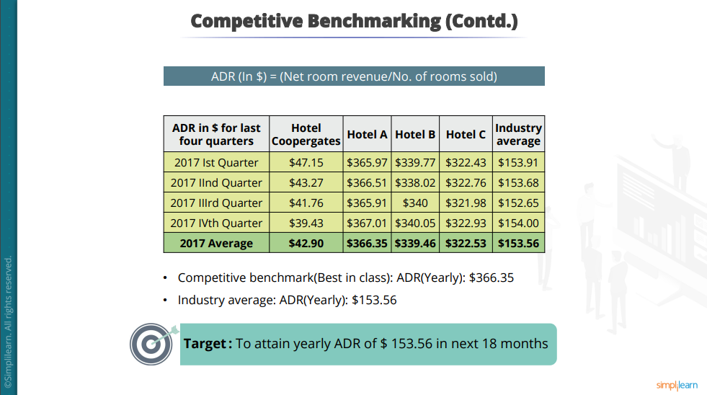

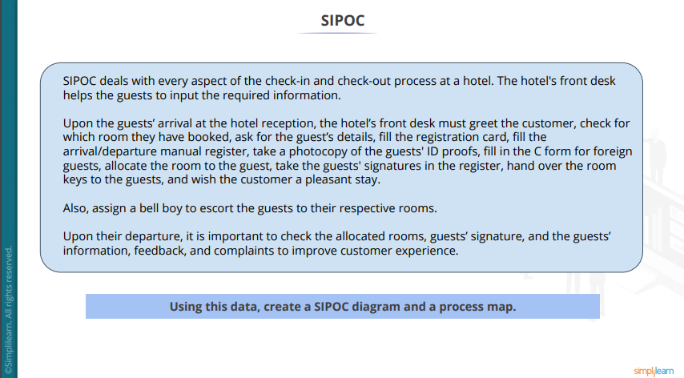

## SIPOC

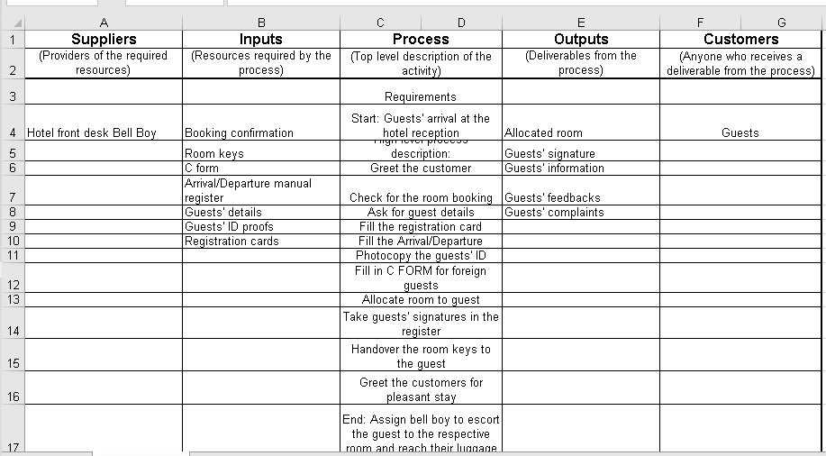

# Measure Phase

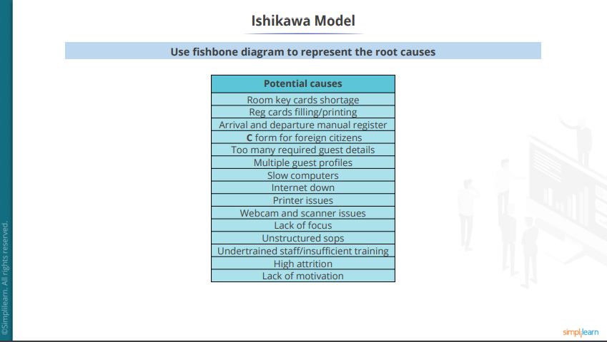

## Fishbone Diagram

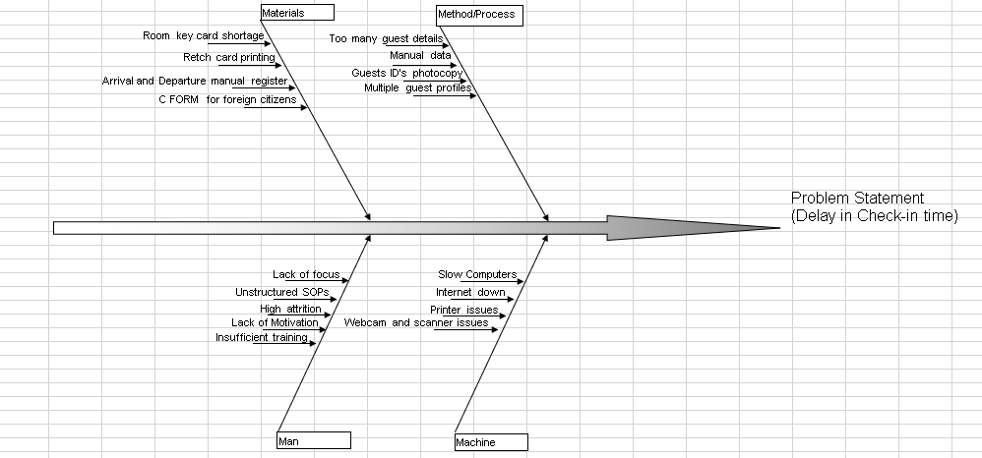

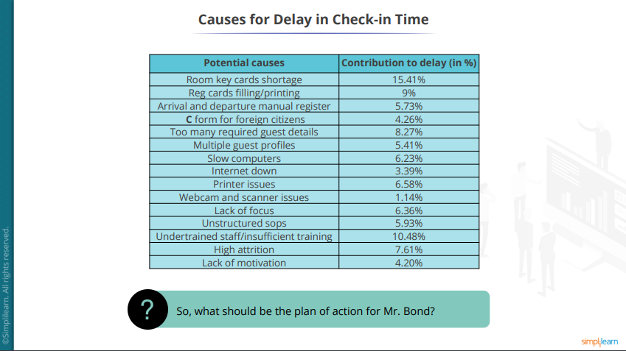

## Pareto chart – causes for delay in check-in time

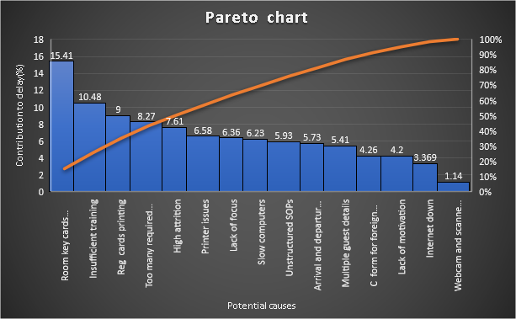

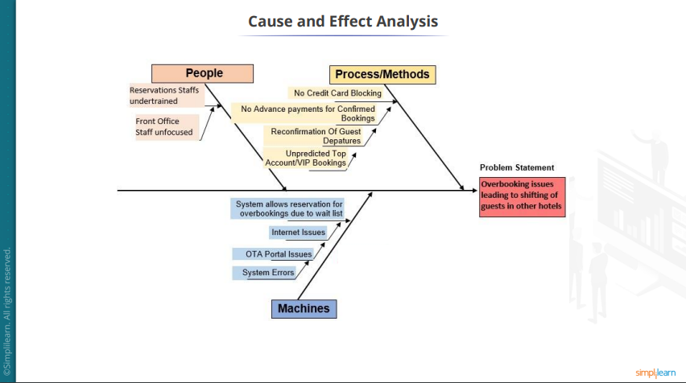

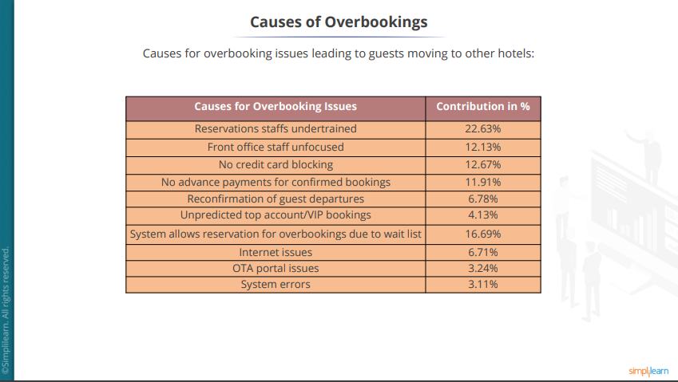

## Perto chart – Causes of overbookings

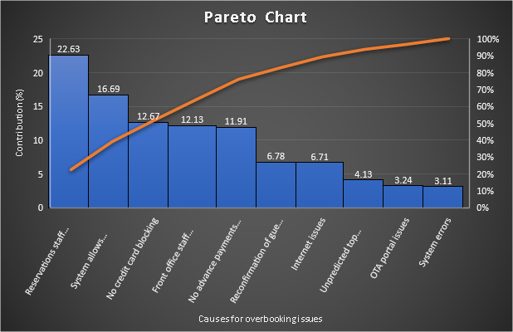

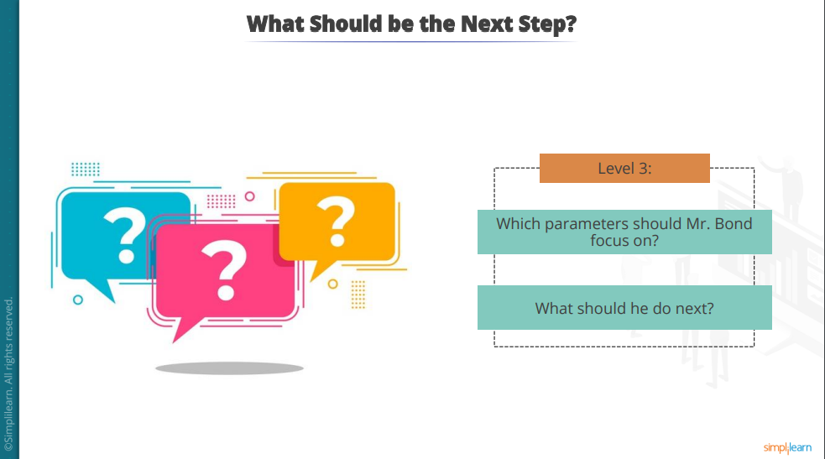

**Mr. Bond has to focus on the following:**

* + Room key card shortage
  + Insufficient staff
  + Reg cards printing
  + Reservations staff under-trained
  + The system allows reservations for overbookings due to waitlist
  + No credit card blocking

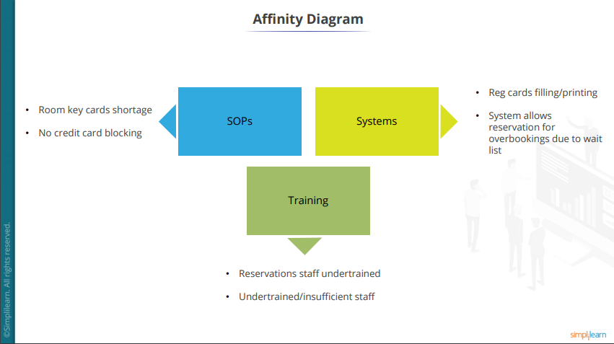

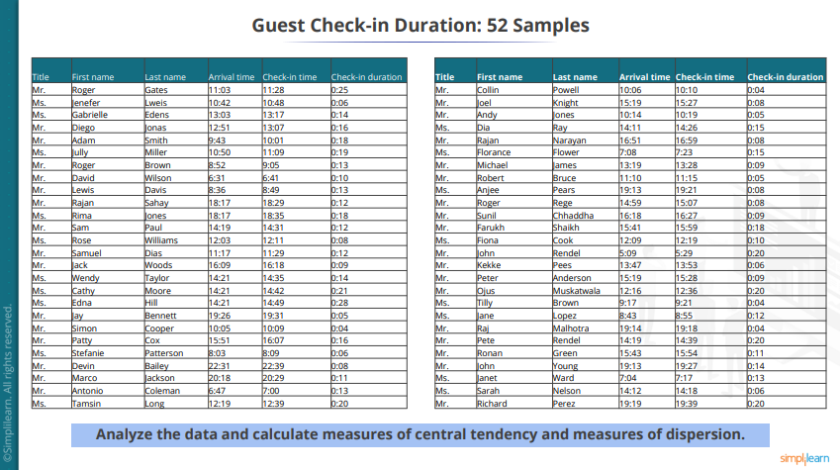

## Analysis of Guest check-in duration

**Measure of Central Tendency:**

**Mean = 12 minutes**

**Median = 12 minutes**

**Mode = 8 minutes**

**Target Mean = 4 minutes**

**Measures of Dispersion:**

**Range = 21 minutes**

**Standard Deviation = 5 minutes**

## Process Stability Check

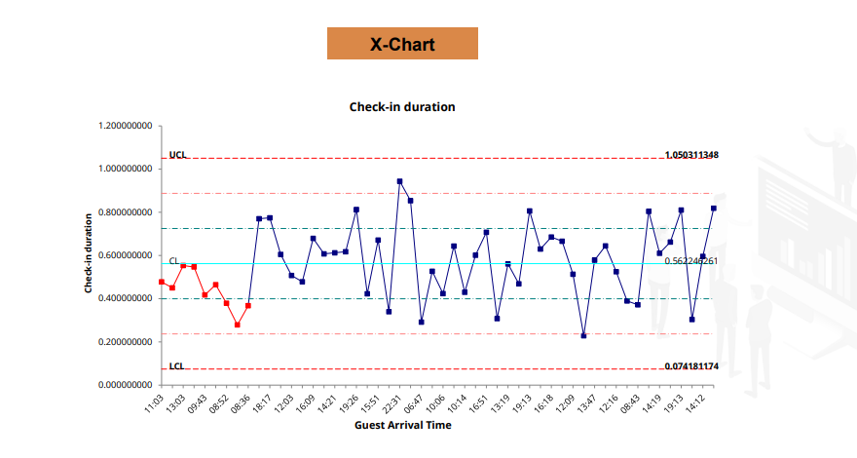

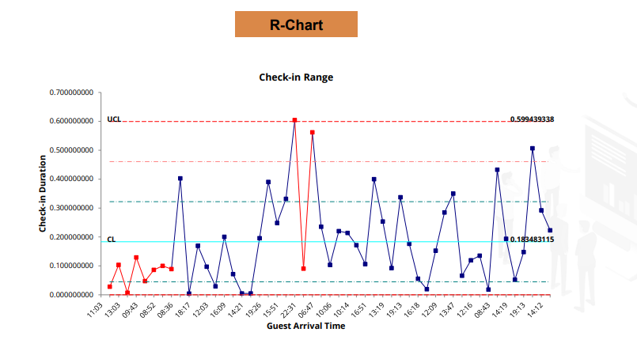

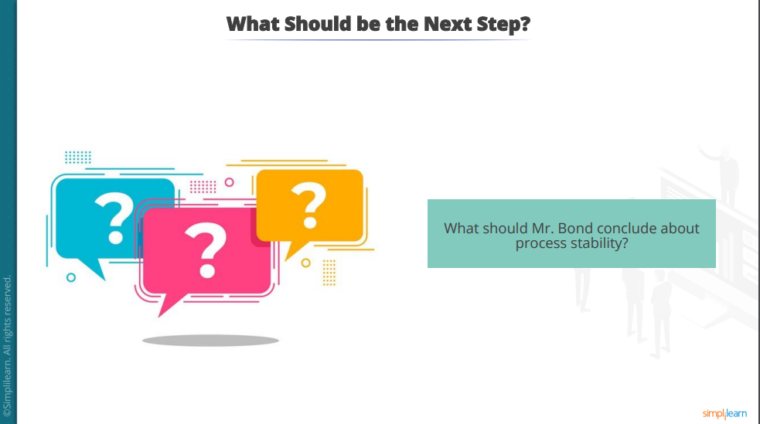

## Process stability

|  |  |
| --- | --- |
| **Current Observation** | * Actual mean check-in duration is 8 minutes more than the target mean check-in duration. * Large variation in the process is observed * XMR chart also shows out-of-control situations in check-in duration data |

|  |  |
| --- | --- |
| **Plan of Actions** | * The mean check-in duration has to be reduced to 6 minutes. * Variation in the process needs to be reduced by 50%. * Process capabilities to be established after stabilizing the check-in process |

# Analyse Phase

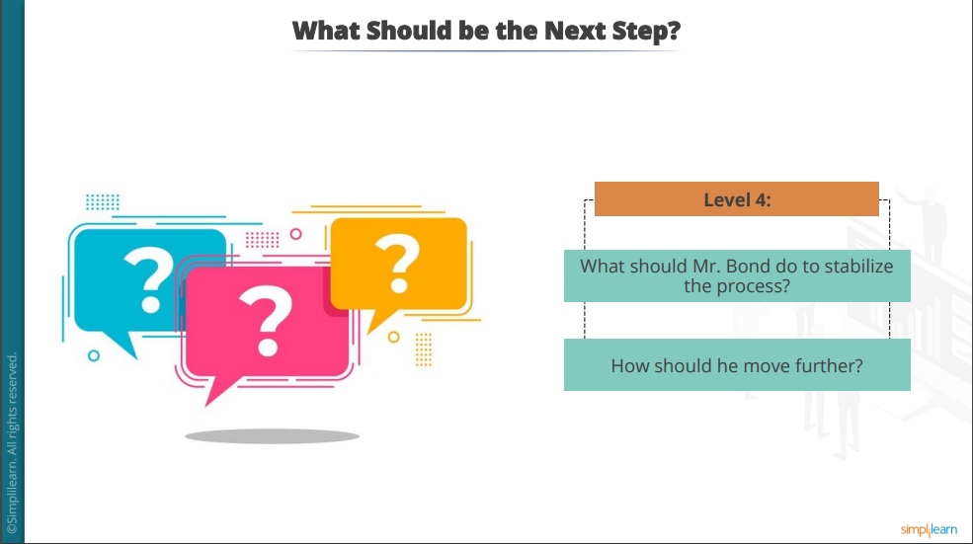

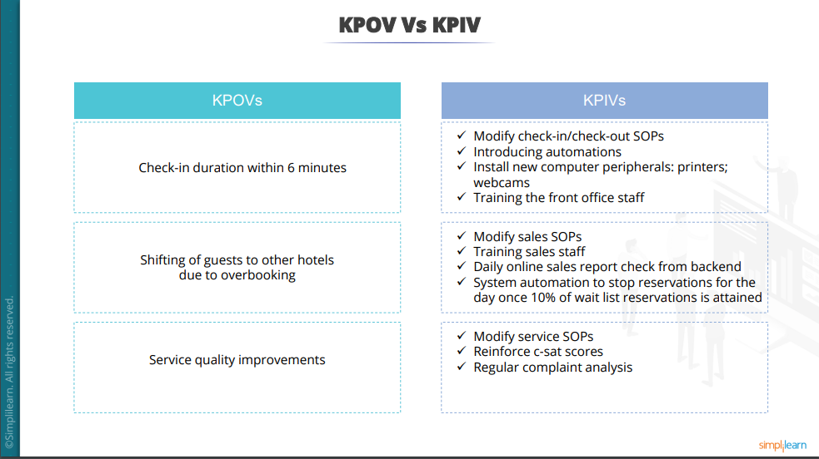

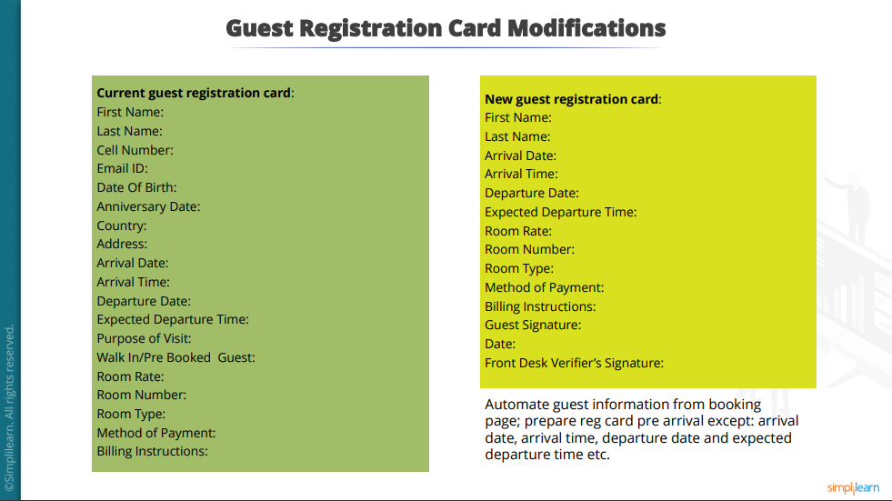

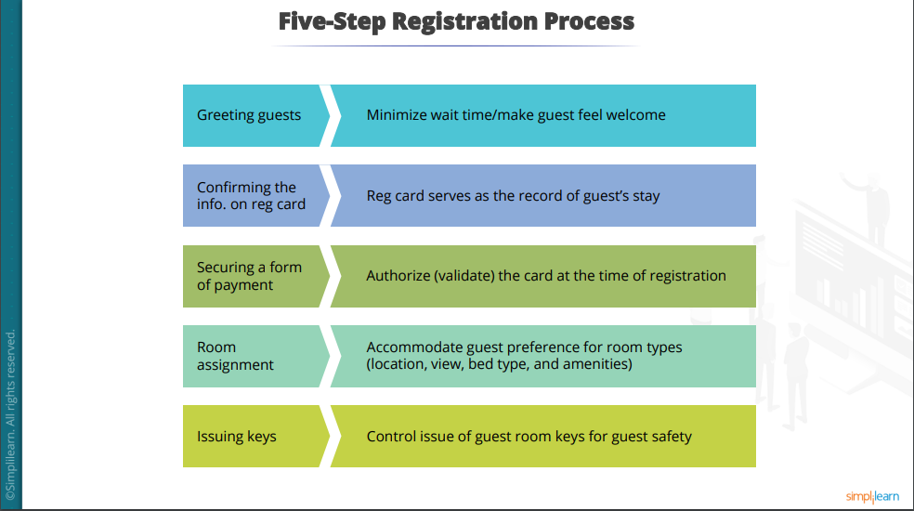

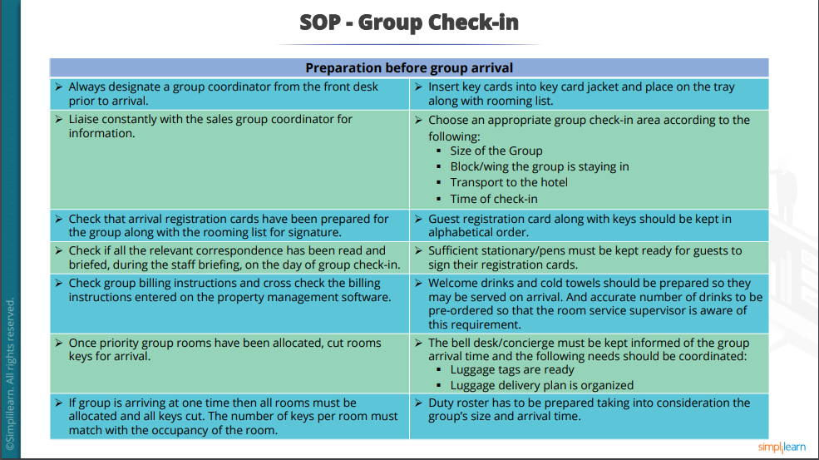

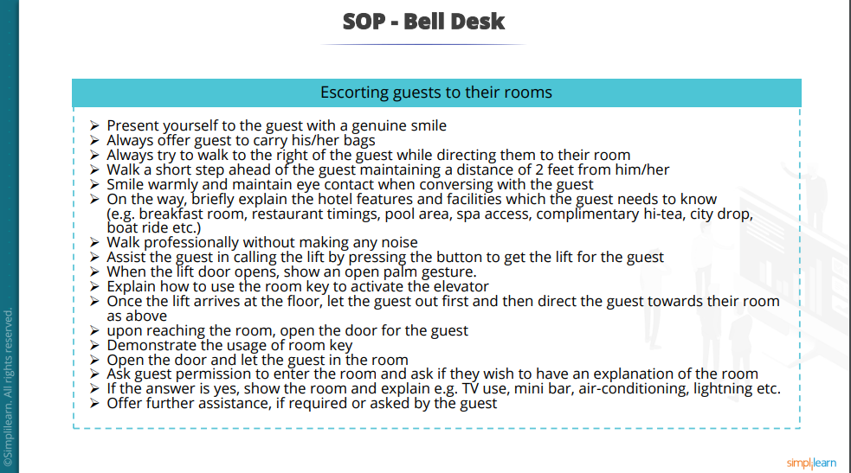

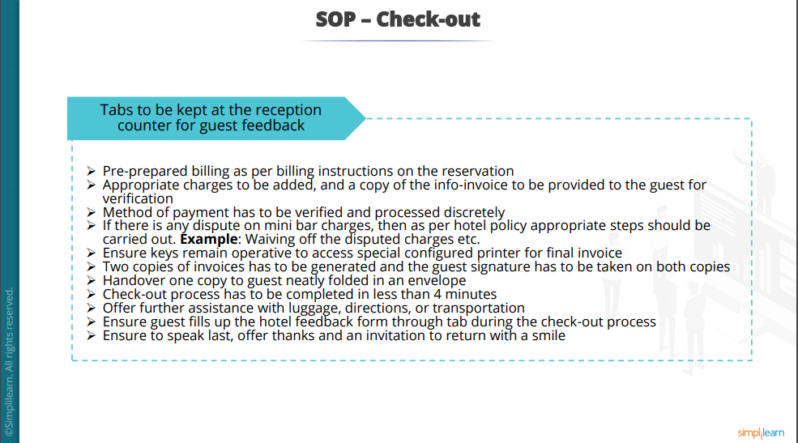

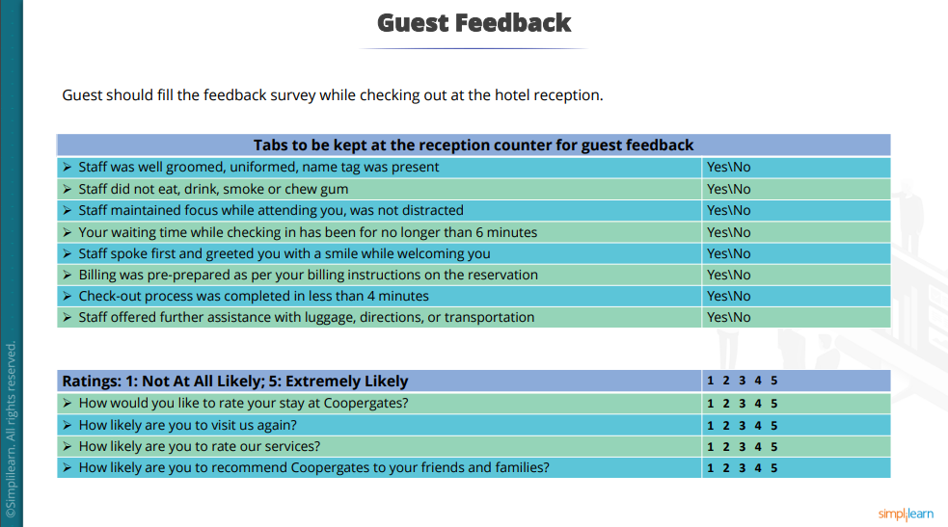

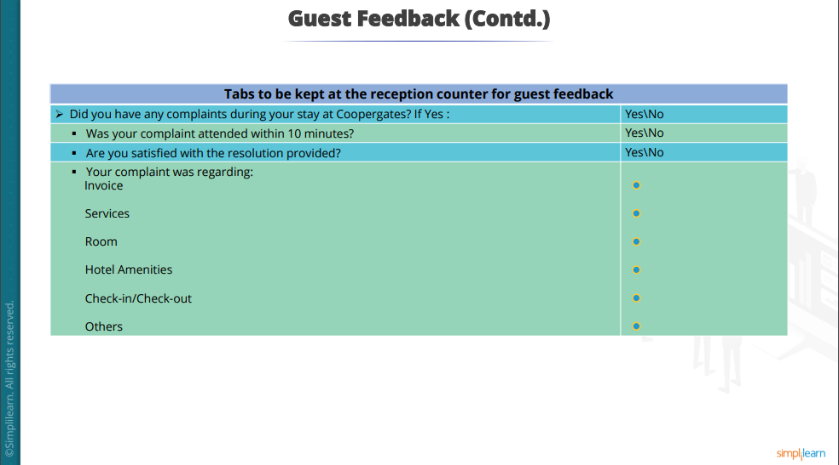

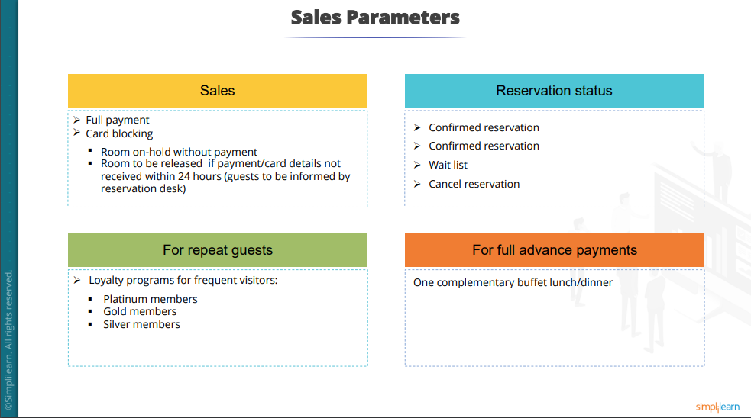

# Improve Phase

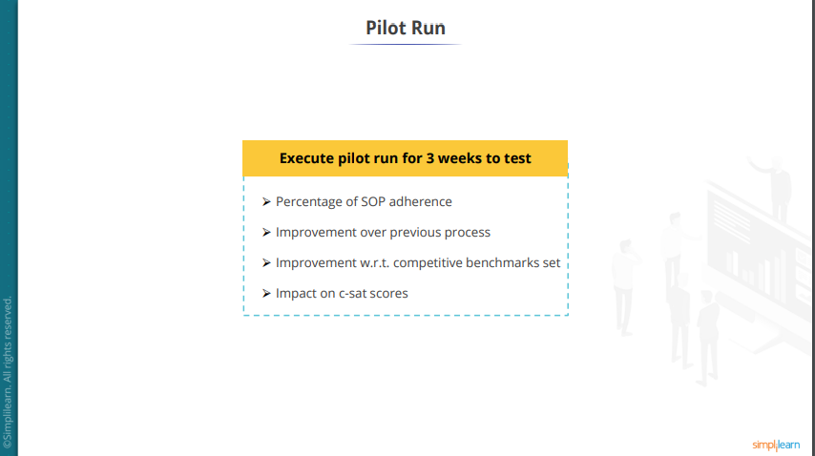

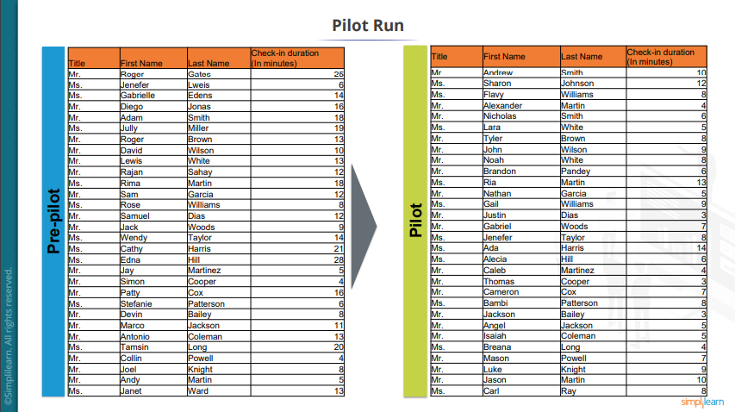

## Pilot test – T-test

|  |
| --- |
| **Analysis of the pre-pilot data with the pilot for check-in duration** |
| * Null hypothesis: Pre-pilot mean is similar to the pilot mean * Alternate hypothesis: Pre-pilot mean is dis-similar to pilot mean |

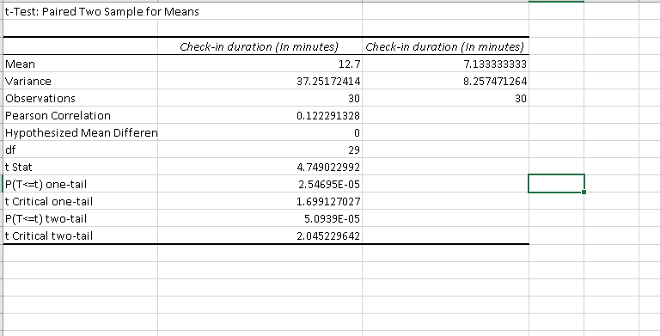

**Inference: Null hypothesis I rejected since p-value < 0.05**

## Pilot test – F-test

|  |
| --- |
| **Analysis of the pre-pilot data with the pilot for check-in duration** |
| * Null hypothesis: Pre-pilot c-sat mean is similar to the pilot c-sat mean * Alternate hypothesis: Pre-pilot c-sat mean is dis-similar to pilot c-sat mean |

|  |  |  |
| --- | --- | --- |
| **Performed F- test Two-sample for variances** | | |
|  | Variable 1 | Variable 2 |
| Mean | 54.975 | 90.55 |
| Variance | 1008.23 | 50.51026 |
| Observations | 40 | 40 |
| df | 39 | 39 |
| F | 19.9609 |  |
| P(F<=f) one tail | 2.53E-16 |  |
| F critical one-tail | 1.704465 |  |

**Inference: Null Hypothesis is rejected since p-value < 0.05**

## Chi-Square test

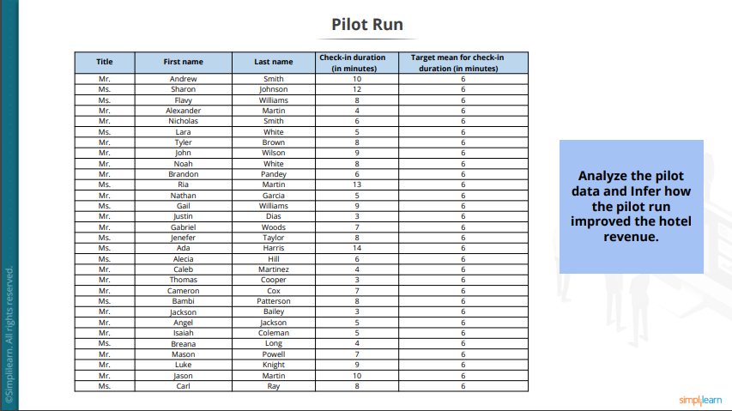

|  |
| --- |
| **Analysis of pilot data** |
| * The pilot has improved the check-in process bringing the check-in mean down by 4.88 minutes * Pilot has reduced variation in the check-in process by 52.95% * C-sat scores have improved by 64.72% |

|  |
| --- |
| **Analysis of the pilot for check-in duration with the target mean** |
| * Null hypothesis: The pilot check-in mean is similar to the target check-in mean * Alternate hypothesis: The pilot check-in mean is dissimilar to the target check-in mean |

|  |  |
| --- | --- |
| **Performed Chi-squared test** | |
| **Mean** | **15.26732008** |
| **P** | **0.982818293** |

**Inference: Null hypothesis is accepted since p-value < 0.05**

# Control Phase

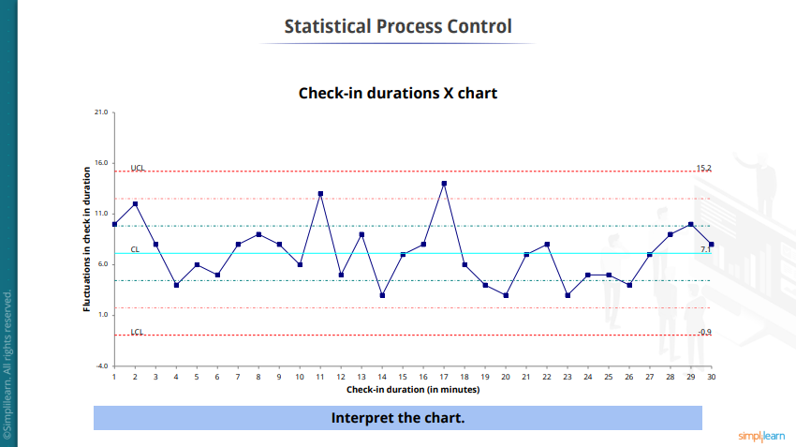

## Control Phase: Final steps

1. Now the process is control and stable

1.

2. Variations are observed due to common causes

3. Implement the suggested changes and monitor the process

# Conclusion:

**Factors that Led to Loss of Revenue:**

The factors that lead to revenue loss at the Hotel Coopergates were a delay in guest

check-in time that led to an overall delay in the hotel's operations. Another factor was the

rampant incidences of overbooking at the premises, and poor quality of services provided the

hotel's staff members. Other factors that had a low impact on the problem lost sales were

unfriendly hotel staff, poor room maintenance practices, high room rate and wrong invoices

to the customers.

**Benefits of Pilot Run to the Hotel Revenue:**

The pilot runs improved the guest check-in time by 4.88 minutes in addition to

reducing variations in the guest check-in procedure by 52.95 percent. Furthermore, the pilot

runs enhanced the customer satisfaction score by 64.72 percent at the Hotel